Peer feedback forms

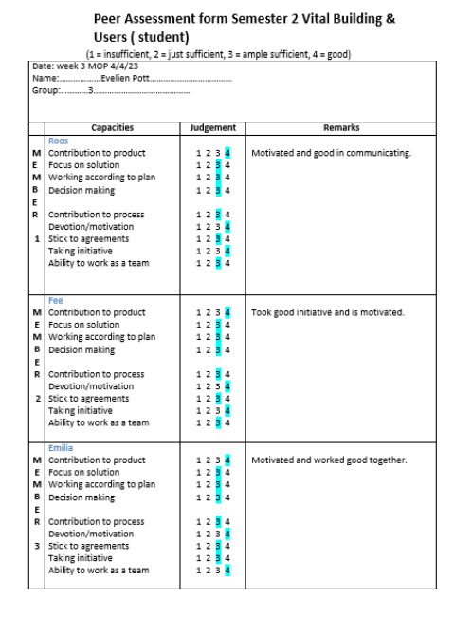
Evelien:

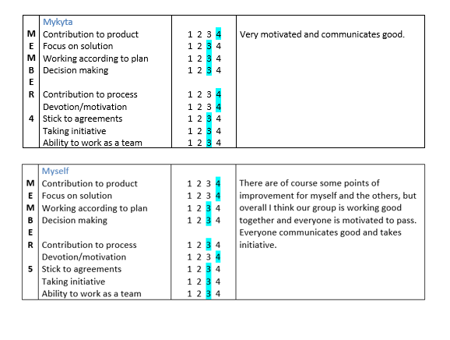

Roos:
Date: 24/04/2026
Name: Roos van der Weij
Group: 3

 | Capacities | Judgement | Remarks
MEMBER  1  Emilia | Contribution to product  Focus on solution  Working according to plan  Decision making  Contribution to process  Devotion/motivation  Stick to agreements  Taking initiative  Ability to work as a team | 1 2 3 4  1 2 3 4  1 2 3 4  1 2 3 4  1 2 3 4  1 2 3 4  1 2 3 4  1 2 3 4  1 2 3 4 | Replied quickly to messages in the group chat and came with solutions when necessary. Thought along with the rest of the group, and did the work that had to be done. Had own initiative.
MEMBER  2  Evelien | Contribution to product  Focus on solution  Working according to plan  Decision making  Contribution to process  Devotion/motivation  Stick to agreements  Taking initiative  Ability to work as a team | 1 2 3 4  1 2 3 4  1 2 3 4  1 2 3 4  1 2 3 4  1 2 3 4  1 2 3 4  1 2 3 4  1 2 3 4 | Did what the group agreed upon doing and made sure to keep in touch with the group mates. Was motivated, and finished work timely.
MEMBER  3  Fee | Contribution to product  Focus on solution  Working according to plan  Decision making  Contribution to process  Devotion/motivation  Stick to agreements  Taking initiative  Ability to work as a team | 1 2 3 4  1 2 3 4  1 2 3 4  1 2 3 4  1 2 3 4  1 2 3 4  1 2 3 4  1 2 3 4  1 2 3 4 | Was hard working and thought along with the rest, and came with own initiative. Kept in contact with project group. Made sure to finish work on time, and asked for help when necessary.
MEMBER  4  Mykyta | Contribution to product  Focus on solution  Working according to plan  Decision making  Contribution to process  Devotion/motivation  Stick to agreements  Taking initiative  Ability to work as a team | 1 2 3 4  1 2 3 4  1 2 3 4  1 2 3 4  1 2 3 4  1 2 3 4  1 2 3 4  1 2 3 4  1 2 3 4 | Had initiative and did their best to make the project successful. Worked hard and kept good contact with the group. Finished work timely.
I  MEMBER  5  Roos | Contribution to product  Focus on solution  Working according to plan  Decision making  Contribution to process  Devotion/motivation  Stick to agreements  Taking initiative  Ability to work as a team | 1 2 3 4  1 2 3 4  1 2 3 4  1 2 3 4  1 2 3 4  1 2 3 4  1 2 3 4  1 2 3 4  1 2 3 4 | Tried to be available and reply to messages. Was able to check other people’s work and tried to stick to agreements. Could have taken more initiative here and there.

Mykyta:
Date: week 3 MOP 4/4/23
Name:Mykyta Kolesnychenko
Group: 3

 | Capacities | Judgement | Remarks
MEMBER  1  Fee | Contribution to product  Focus on solution  Working according to plan  Decision making  Contribution to process  Devotion/motivation  Stick to agreements  Taking initiative  Ability to work as a team | 1 2 3 4  1 2 3 4  1 2 3 4  1 2 3 4  1 2 3 4  1 2 3 4  1 2 3 4  1 2 3 4  1 2 3 4 | Worked hard, shared ideas, and kept the group updated. Finished my tasks on time and wasn't afraid to ask for help.
MEMBER  2  Emilia | Contribution to product  Focus on solution  Working according to plan  Decision making  Contribution to process  Devotion/motivation  Stick to agreements  Taking initiative  Ability to work as a team | 1 2 3 4  1 2 3 4  1 2 3 4  1 2 3 4  1 2 3 4  1 2 3 4  1 2 3 4  1 2 3 4  1 2 3 4 | Was responsive, proactive, and a solid problem-solver who consistently took initiative.
MEMBER  3  Roos | Contribution to product  Focus on solution  Working according to plan  Decision making  Contribution to process  Devotion/motivation  Stick to agreements  Taking initiative  Ability to work as a team | 1 2 3 4  1 2 3 4  1 2 3 4  1 2 3 4  1 2 3 4  1 2 3 4  1 2 3 4  1 2 3 4  1 2 3 4 | Communicated very well and took initiative. Seems very motivated, and does work in time.
MEMBER  4  Evelien | Contribution to product  Focus on solution  Working according to plan  Decision making  Contribution to process  Devotion/motivation  Stick to agreements  Taking initiative  Ability to work as a team | 1 2 3 4  1 2 3 4  1 2 3 4  1 2 3 4  1 2 3 4  1 2 3 4  1 2 3 4  1 2 3 4  1 2 3 4 | Was a reliable, motivated team player who communicated consistently and met every deadline.
MEMBER  5  Mykyta | Contribution to product  Focus on solution  Working according to plan  Decision making  Contribution to process  Devotion/motivation  Stick to agreements  Taking initiative  Ability to work as a team | 1 2 3 4  1 2 3 4  1 2 3 4  1 2 3 4  1 2 3 4  1 2 3 4  1 2 3 4  1 2 3 4  1 2 3 4 | Took responsibility on decision making and dividing tasks, shared the ideas and was trustworthy

Emilia:
Date: 24.04.2026
Name: Emilia Hansen
Group: 3

 | Capacities | Judgement | Remarks
MEMBER  2 | Evelien  Contribution to product  Focus on solution  Working according to plan  Decision making  Contribution to process  Devotion/motivation  Stick to agreements  Taking initiative  Ability to work as a team | 1 2 3 4  1 2 3 4  1 2 3 4  1 2 3 4  1 2 3 4  1 2 3 4  1 2 3 4  1 2 3 4  1 2 3 4 | Communicated well, was motivated and did good work in time. Helped others when necessary.
MEMBER  3 | Fee  Contribution to product  Focus on solution  Working according to plan  Decision making  Contribution to process  Devotion/motivation  Stick to agreements  Taking initiative  Ability to work as a team | 1 2 3 4  1 2 3 4  1 2 3 4  1 2 3 4  1 2 3 4  1 2 3 4  1 2 3 4  1 2 3 4  1 2 3 4 | Took good initiative and did good work. Communicated well with the rest of the group, helped others out and asked for help aswell.
MEMBER  4 | Mykyta  Contribution to product  Focus on solution  Working according to plan  Decision making  Contribution to process  Devotion/motivation  Stick to agreements  Taking initiative | 1 2 3 4  1 2 3 4  1 2 3 4  1 2 3 4  1 2 3 4  1 2 3 4  1 2 3 4  1 2 3 4  1 2 3 4 | Communicated very well and took initiative. Seems very motivated, and does work in time.
MEMBER  4 | Roos  Contribution to product  Focus on solution  Working according to plan  Decision making  Contribution to process  Devotion/motivation  Stick to agreements  Taking initiative  Ability to work as a team | 1 2 3 4  1 2 3 4  1 2 3 4  1 2 3 4  1 2 3 4  1 2 3 4  1 2 3 4  1 2 3 4  1 2 3 4 | Does work on time and communicates vey well. Sticks to agreements and helps others when necessary.

MEMBER  4 | Myself  Contribution to product  Focus on solution  Working according to plan  Decision making  Contribution to process  Devotion/motivation  Stick to agreements  Taking initiative  Ability to work as a team | 1 2 3 4  1 2 3 4  1 2 3 4  1 2 3 4  1 2 3 4  1 2 3 4  1 2 3 4  1 2 3 4  1 2 3 4 | There is always room for improvement, but I think this group communicated very well and helped each other when needed. Everyone is motivated to pass, which helps me stay motivated as well.  I could have been more active in decision making and taking initiative.  Personally I am very happy with the group members and the product.

Fee:
Date: week 3 MOP 4/4/23
Name: Fee Heeroma
Group: 3

 | Capacities | Judgement | Remarks
MEMBER  1  M  Y  K  Y  T  A | Contribution to product  Focus on solution  Working according to plan  Decision making  Contribution to process  Devotion/motivation  Stick to agreements  Taking initiative  Ability to work as a team | 1 2 3 4  1 2 3 4  1 2 3 4  1 2 3 4  1 2 3 4  1 2 3 4  1 2 3 4  1 2 3 4  1 2 3 4 | Mykyta took a lot of initiative and ensured a good end result. He took on a lot of work and made sure everything looked good. He also finished his work on time. I found the collaboration very pleasant and did not encounter any further difficulties.
MEMBER  2  R  O  O  S | Contribution to product  Focus on solution  Working according to plan  Decision making  Contribution to process  Devotion/motivation  Stick to agreements  Taking initiative  Ability to work as a team | 1 2 3 4  1 2 3 4  1 2 3 4  1 2 3 4  1 2 3 4  1 2 3 4  1 2 3 4  1 2 3 4  1 2 3 4 | Roos was motivated to perform her work as well as possible. She interacted frequently with the group and asked for help when necessary. Roos also ensured that her work was finished on time. I found the collaboration very pleasant and did not encounter any further difficulties.
MEMBER  3  E  V  E  L  I  E  N | Contribution to product  Focus on solution  Working according to plan  Decision making  Contribution to process  Devotion/motivation  Stick to agreements  Taking initiative  Ability to work as a team | 1 2 3 4  1 2 3 4  1 2 3 4  1 2 3 4  1 2 3 4  1 2 3 4  1 2 3 4  1 2 3 4  1 2 3 4 | Evelien ensured that she was involved with the group as much as possible and took her own work seriously. She ensured that her work was completed well and submitted her work on time. I found the collaboration very pleasant and did not encounter any further difficulties.
MEMBER  4  E  M  I  L  I  A | Contribution to product  Focus on solution  Working according to plan  Decision making  Contribution to process  Devotion/motivation  Stick to agreements  Taking initiative  Ability to work as a team | 1 2 3 4  1 2 3 4  1 2 3 4  1 2 3 4  1 2 3 4  1 2 3 4  1 2 3 4  1 2 3 4  1 2 3 4 | Emilia ensured that she took on her own tasks and also suggested which task she would like to do. She finished her work on time, had good interactions with the group, and was eager to help where needed. I found the collaboration very pleasant and did not encounter any further difficulties.
MEMBER  4  F  E  E | Contribution to product  Focus on solution  Working according to plan  Decision making  Contribution to process  Devotion/motivation  Stick to agreements  Taking initiative  Ability to work as a team | 1 2 3 4  1 2 3 4  1 2 3 4  1 2 3 4  1 2 3 4  1 2 3 4  1 2 3 4  1 2 3 4  1 2 3 4 | I feel that I had sufficient motivation and perseverance during this project to meet all the requirements. It was difficult at the beginning, but thanks to good collaboration, we still achieved a great final result that I am proud of.

